During Check-in, I found that my KTN disappeared overnight for what reason? Document check took a while (I used a Visa, but it was in my old passport, which is allowed). The person checking my documents was friendly and kind.

I boarded with Group 1 through the blue lane… I was the third person onboard. This flight is elite-light.

After I sat down, a very kind flight attendant came to take my PDB order. I had a coffee, which I had plenty of time to drink. It was served in a paper cup.

Now, I took pictures of the flight using my iPhone Xr. I hate using my camera in dark mode, but my iPhone works well.

The captain came out to greet all of us sitting in First Class… he was definitely festive and it sounded like he loved his job. Or it was Christmas… either way is fine with me. I could definitely hear that festive tone in his announcements.

DirecTV is provided on this flight (trade-off on Boeing Sky Interior for this case, but I don’t argue when it’s First Class).

DirecTV failed on me. It was free for everyone, but I tried to watch FOX News, and it failed. I tried CNN, also failed… the entire flight. With no sport event yet (too early), I just chilled.

We took off early… Captain said we’d be leaving on Runway 12L (“That’s right behind us”).

And screens don’t turn off. No power button, but turning the brightness all the way down helped in the sense that the screens went out when turned to the dimmest setting. First class went out half full so there were some flashing screens.

I had a coffee… it was served in a mug.

I enjoyed a warm blueberry muffin that was brought out, it was delicious. Looking at my tray table, I could sense something missing. I went to the Flight Attendant serving my cabin.

When I went to the bathroom, the Flight Attendant asked if he could serve me. I asked for some stroopwafels if there are any left from back there. He agreed to check for me. Little did I know I would be getting more than I needed…

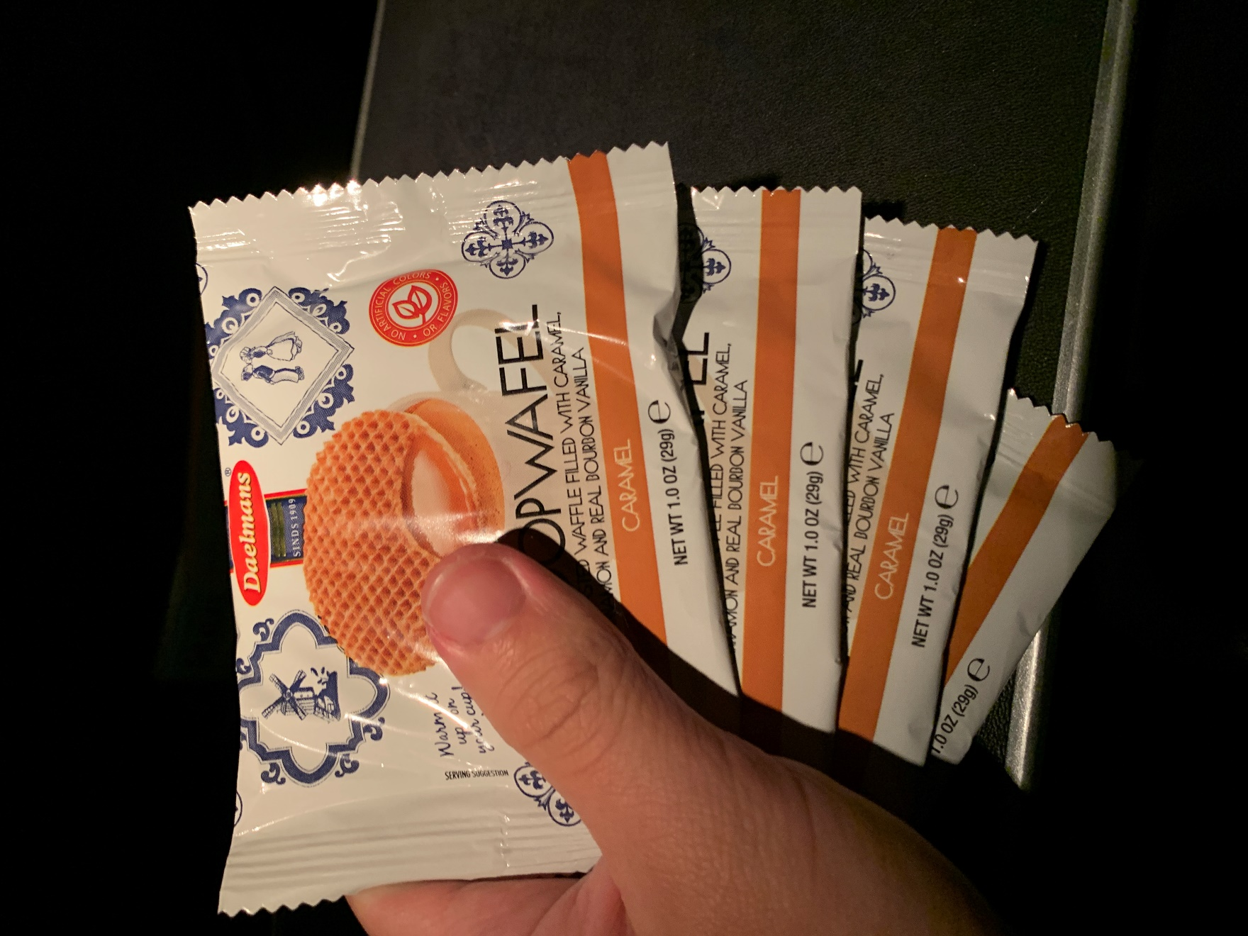

He came back with four! Well, the thought was nice, and I definitely enjoyed it. I had one and saved the other three for later.

We landed 29 minutes early… score! The captain said we had one of the gates on the edge, but he joked that it’s some good exercise.

I loved the service on the flight. It’s the little thing that counts (such as bringing more food than requested) and I appreciated the muffin and the PDB. I could also tell that the captain was in a festive mood because I never seen them come out to introduce themselves and thank us for flying.

Also, definitely my best United First Class experience to-date (taking into account Chicago to Minneapolis a week later). Because of the service. And the emptier flight.